**BF[2] – Enrichment Cortland Watson**

**Type in your score here 🡪 __30__ out of 30 points possible**

1. (5 points) Ponder/Reflect Exercise – Reflect on what you have learned from this portion of the class. Examples of what you can do are: a brief outline of material covered, insights you gained from class or personal study, or items you feel that you need to follow up or work on. (3-5 sentences)
   1. This week I have been able to learn a lot more about basic factorial designs. I was especially interested to learn about interactions and how this plays a role in our analysis. It is through the interaction that we can determine how much one variable accounts for the response, but at the same time consider all other possibilities. I really liked though how the interaction can hold significance, without the variables themselves having such.
2. Do a complete ANOVA on cancer file (cancer.txt). Fit an ANOVA model that includes terms for gender (“f” or “m”), cancer type, and the interaction between gender and cancer type.
   1. (5 points) Find the complete ANOVA table USING TYPE I SS. Carry out the complete analysis considering the decision flow diagram discussed in class for two-way ANOVA. Give a complete interpretation for each of the terms in the model.
      1. 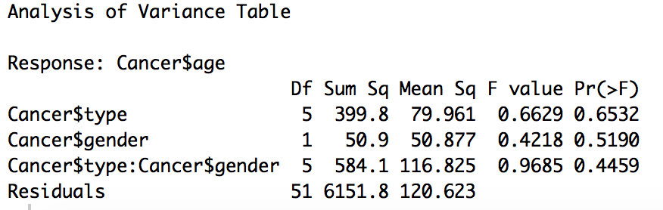
      2. In all cases, type, gender and interaction, our p-value is high. Therefore, we fail to reject the null hypothesis that the population means of these groups are the same. At the same time, we fail to reject the null hypothesis that an interaction does not exist. In conclusion, type and gender have no significant impact on the age of patients and that there is not interaction effecting the same response.
   2. (5 points) Find the complete ANOVA table USING TYPE III SS. Carry out the complete analysis considering the decision flow diagram discussed in class for two-way ANOVA. Give a complete interpretation for each of the terms in the model.
      1. 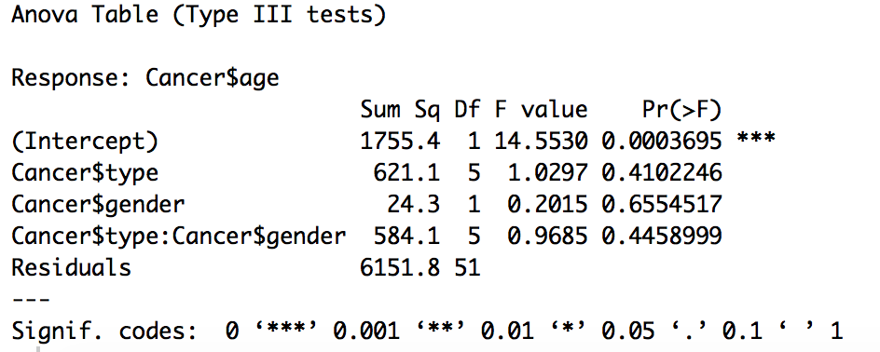
      2. After running the type III SS we still find the same results. The analysis shows that we still have insufficient evidence to reject the null hypothesis that the population means for type and gender are different and that there is an interaction between type and gender.
3. Do a complete analysis of variance on heights of singers in a choir, found in the file singerheights.csv (note that it is comma-delimited). Fit an ANOVA model that includes terms for gender (“f” or “m”), singing part (“low” or “high”), and the interaction between gender and part. (Note that the low part for females is generally called alto, high part for females is soprano, low part for males is bass, and high part for males is tenor. However, we are interested in the association between singing the high/low part and height, so we are treating this as a 2 x 2 factorial instead of a one-way Anova with 4 levels of “singing part.”)
   1. (5 points) Find the complete ANOVA table USING TYPE I SS. Carry out the complete analysis considering the decision flow diagram discussed in class for two-way ANOVA. Give a complete interpretation for each of the terms in the model.
      1. 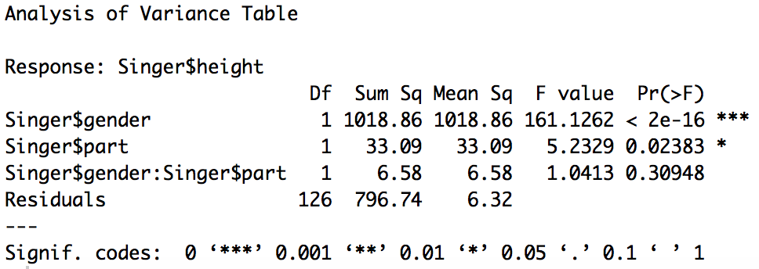
      2. In this analysis we are able to see that we can reject the main Null hypothesis for gender and part. They both show that at least one of the population means is different. As for the interaction between the both of them, there is not sufficient evidence to reject the null hypothesis. In other words, there is not interaction.
   2. (5 points) Find the complete ANOVA table USING TYPE III SS. Carry out the complete analysis considering the decision flow diagram discussed in class for two-way ANOVA. Give a complete interpretation for each of the terms in the model.
      1. 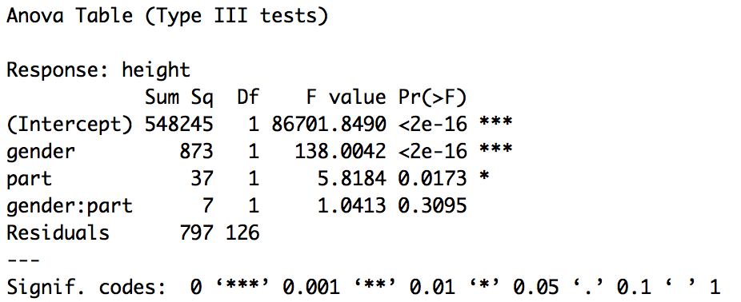
      2. In this analysis we are able to see that we can reject the main Null hypothesis for gender and part. They both show that at least one of the population means is different. As for the interaction between the both of them, there is not sufficient evidence to reject the null hypothesis. In other words, there is not interaction.
   3. (2 points) Why is the SS for gender so much smaller with Type III SS? Explain.
      1. I do not know for sure, but it has something to do with using the gender variable first, which allows for some of the SS to be available later on and then assigned to gender later?
4. (3 pts) What are the main reasons we want to use replication (more than one unit per treatment group)?
   1. Replication helps us to be more accurate with what we find. We are also able to find more accurate residuals by using replications. This is extremely helpful when we are doing the decomposition as well.